The Tribe Of Zebulon
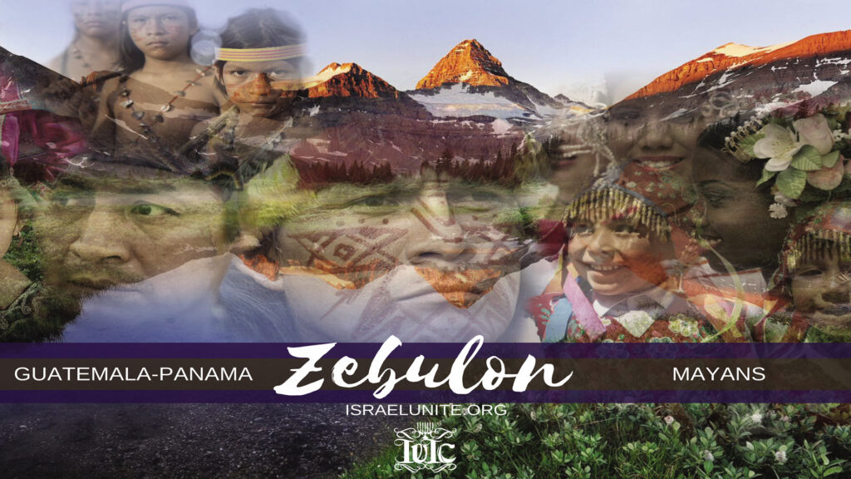

Zebulun, was the tenth born son of Jacob. His name means. “My Dwelling”. They migrated to the Americas, in 536 B.C. during the Persian captivity.
Genesis 49:1 “And Jacob called unto his sons, and said. ‘Gather yourselves together, that I may tell you that which shall befall you in the last days’” The last days occur from the days of Christ till today Read Hebrews 1:2.
Genesis 49:13, “Zebulun shall dwell at the haven of the sea; and he shall be an haven of ships;” an haven of the sea and an haven for ships, is speaking of the Panama Canal.
This canal was opened to shipping in 1914, it connects the Atlantic and the Pacific oceans, and shortens the amount of time and distance needed to bring valuable cargo to America. In 1965, the U.S. and Panama, signed an agreement recognizing Panama’s complete sovereignty (control) over the Canal Zone in the year 2000, when America relinquishes her control over the Canal Zone to Panama. There was one stipulation however, if for whatever reason Panama’s military could not properly safeguard the canal by said time (the year 2000) America, would remain as the canals sovereign ruler. Under the Bush Administration. General Manuel Noriega (who was trained by the C. I. A,) was accused of drug trafficking. America (the Bush Administration), then created propaganda in which American citizens were lead to believe Noriega’s drug trafficking threatened Americas national security. Shortly after, the American government invaded Panama, needlessly destroying and murdering thousands of Panama’s citizens and military.
Psalms 73:12, “Behold, these are the ungodly, who prosper in the world; they increase in riches.”
Deuteronomy 33:1, “And this is the blessing wherewith Moses the man of God blessing the children of Israel before his death.
Deuteronomy 33:18, “And of Zebulun he said, Rejoice, Zebulun, in thy going out; and Issachar in thy tents”, this proves Zebulun (Mayans), and Issachar (Aztecs), would live very near each other. The Mayans, would go out of their cities to meet the Aztecs in places of worship within the borders of Mexico; Teotihuacan, at Uxmal, Tocana, Palenque, Chichenitza, Pico de Orizaka, Très Zapotes & La Ventou, etc.
Deuteronomy 33:19, “They shall call the people unto the Mountain;” the Aztecs (Issachar) shall call the people (the Mayans/Zebulun) unto the mountain. “There they shall offer sacrifices of righteousness:”, after Moses died, this meant the Promise Land. Israel. In the last days (A. D.), this also meant the borders of Mexico near Chipas, etc. They erected temples and pyramids, as Israelites have been known to do 1 Maccabees 13: 28
“Moreover he set up seven pyramids, one against another, for his father, and his mother, and his four brethren“. Exodus 1:11 Therefore they did set over them taskmasters to afflict them with their burdens. And they built for Pharaoh Treasure cities, Pithom and Raamses. (Found in Egypt’s Valley of the Kings)
However during the Middle Ages both tribes sacrificed human flesh and were reputed for eating the heart and other human organs.
Hosea 8:13, “They sacrifice flesh for the sacrifices of mine offerings, and eat it; but the Lord accepteth them not; now will he remember the iniquity, and visit their sins; they shall return to Egypt.” Meaning Israel’s 10 tribes would return to bondage/slavery. The word Egypt refers to Bondage according to Exodus 20:2 “I am the LORD thy God; which have brought thee out of the land of Egypt, out of the house of bondage.”
Hosea 8:14, “For Israel hath forgotten his Maker, and buildeth temples….”, in time both the Aztecs and Mayans forgot the True Lord of Israel, and built temples to Quetzalcoah, Tlalac the rain-god and the god Chac etc.
Deuteronomy 33:19, “for they suck (feed) of the abundance of the seas, and of the treasures of hid in the sand”, the abundance of the seas means the thousands of fish they could feed on. The treasures hid in the sand refers to the literal treasures the Mayans buried deep within their sands as well as the gold, silver, etc., that has always been beneath their sands.
Bibliography:
History of the American Indians, by James Adair, Page 214.
“.. the Indian native, from Florida to Panama …, believe in one true, immortal and invisible God, reigning in heaven “,
1 Timothy 1:17, “Now unto the King eternal, immortal, invisible, the only wise God, be honour and glory forever and ever. Amen.” SHALOM

